**Experiment 10**

1. Login to the Jenkins dashboard and head to ‘Manage plugins’ in the ‘Manage Jenkins’ tab.

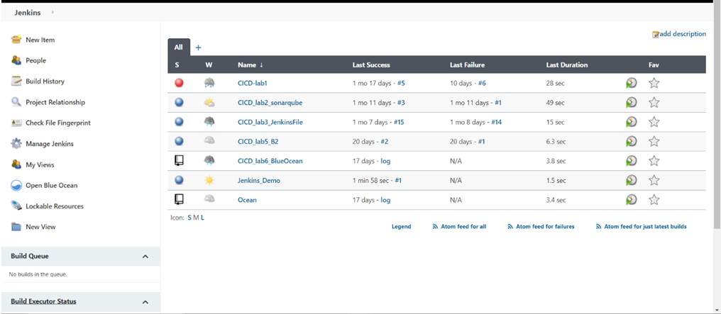

1. Choose ‘Configure system’ and scroll to ‘Sonatype Nexus’ and provide hosting URL and credentials.

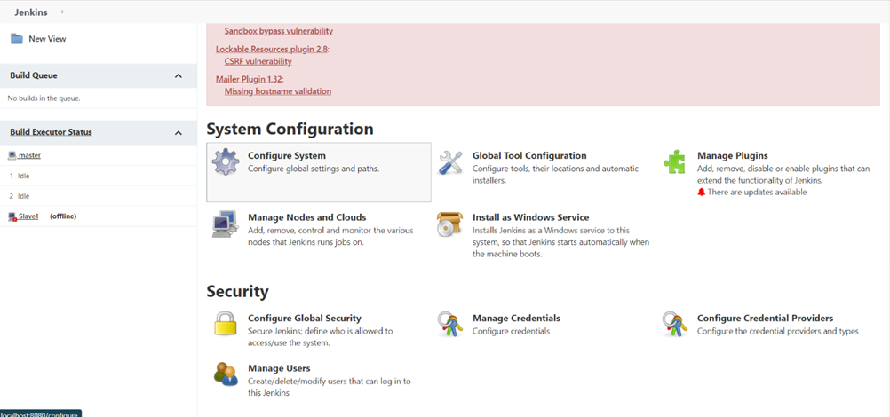

1. Click on “Test Connection” to check connection connectivity.

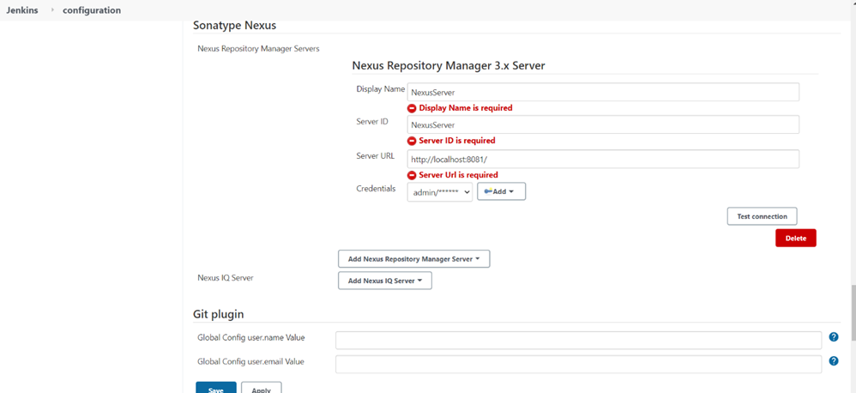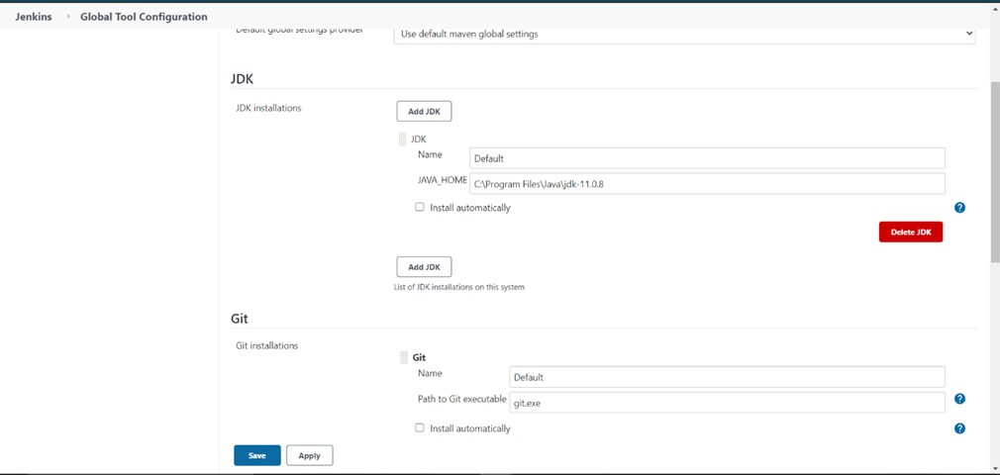

1. Login to the nexus repository manager and create a new repository in it.
2. Copy the repository URL in the pom.xml of the maven

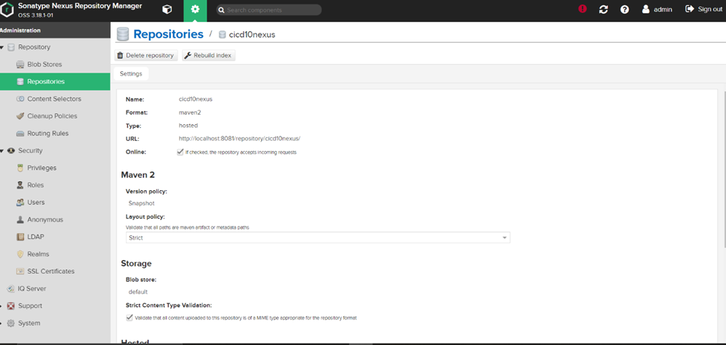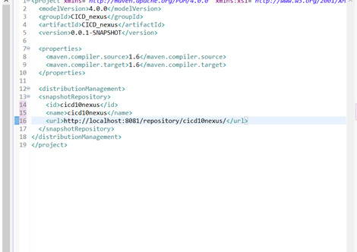

1. Push the project to github and Create a maven project in Jenkins and configure it with the URL of github repo and pom.xml file path.

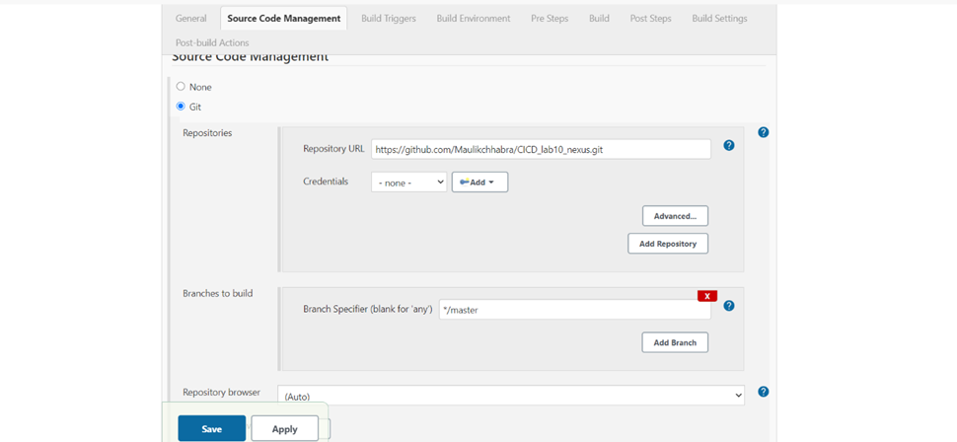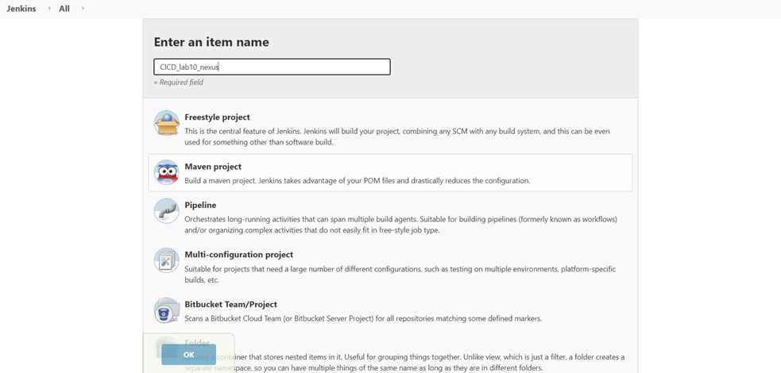

1. Build the project by clicking on ‘Build now’.

